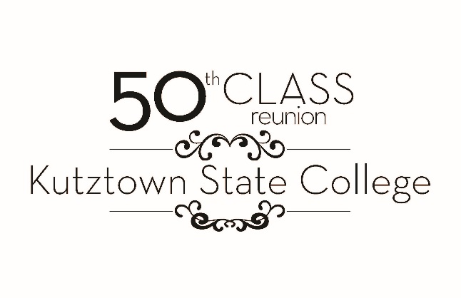

Kutztown University Foundation & Alumni Relations
will provide complimentary regalia to anyone in the Class of 1971
who would like to walk and be recognized
as a class at the May 8, 2021 Commencement.

Complete only if participating in commencement
processional during the 2 PM commencement ceremony on May 8, 2021.

Please complete this form no later than March 12, 2021.

You will receive maroon regalia, a one-size fits all mortar board and
hood based upon your area of study.

Name:
______________________________________________________________________________

Height:
______________________________________________________________________________

Highest degree earned: ______________________________________________________________________________

Area of study:
______________________________________________________________________________

University where degree was obtained:
______________________________________________________________________________

If you have your own regalia, please state what you have below:
______________________________________________________________________________________________________________________________________________________________________________________________________________________________________________________________________________

